**Exercises on High Voltage Engineering (Mar 6, 2025):**

**Exercise 1-14:** The following figure shows the relationship between the initial discharge voltage of the parallel plate electrode system and the gas pressure, so which gap distance *d*1 or *d*2 is larger than the other?

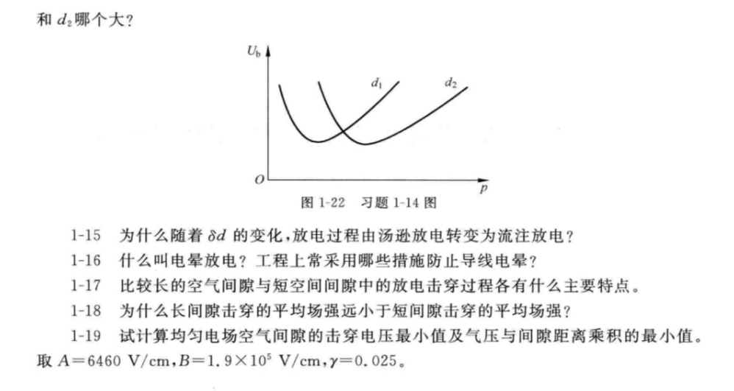

**Exercise 1-15:** Why does the discharge process change from Townsend discharge to streamer discharge with the change of *δd*?

**Exercise 1-16:** What is corona discharge? What measures are often adopted in engineering practice to prevent conductor corona?

**Exercise 1-18:** Why is the average breakdown field strength of long gap much smaller than that of short gap?

**Exercise 2-1:** What are the main stages of lightning discharge?

**Exercise 2-3:** The laboratory has a pair of copper spheres with a diameter of 50cm, and the sphere gap distance can be continuously adjusted in the range of 30~60cm. How many kV is the range of power frequency breakdown voltage for this sphere gap system?

**Supplementary Exercise 1:** Under standard atmosphere conditions, how many kV is the breakdown voltage of positive and negative DC for the extremely non-uniform electric field air gap with a gap distance of 75cm? How many kV is the power frequency breakdown voltage?

**Supplementary Exercise 2:** There is a sphere-plane electrode system with sphere radius is *r* = 4cm and gap distance is *d* = 50cm. What are the corona inception stress *E*0, corona inception voltage *U*c and gap breakdown voltage *U*b respectively? If the gap distance is unchanged and only the radius of the sphere electrode *r* is changed to 1cm, then what is the approximate value of *E*0, *U*c and *U*b respectively?

**Supplementary Exercise 3:** Why the tip of grounded electrode may also produce corona? How to understand that there is no applied voltage in the Peek formula (Formula 1-35 of the textbook) for calculating the corona inception stress of conductor? How to explain the relation between applied voltage and conductor corona in Figure 1-14 of the textbook?

**Supplementary Exercise 4:** There is a air gap parallel cylindrical with *r* = 5 cm, *d* = 50 cm, and a sphere-sphere air gap of *r* = 5 cm, *d* = 20 cm. Which gap has higher corona inception stress, the higher corona inception voltage and the higher breakdown voltage?

**Supplementary Exercise 5:**

(1) In the document on OHLs-1, the photos of a 500kV double-circuit tension small angle transposition tower are given on page 31&32. Please indicate the upper right phase, middle right phase, and lower right phase of the right circuit marked in yellow circle on page 31&32 are turned to which phase at the next tower in the distance of the photo after passing through this tower.

(2) In the document on OHLs-1, the photo of a transposition tension tower and cat head tower are given on page 33. Please indicate the top, left and right phases marked by red circle are turned to which phase of the cat head tower in the distance of the photo after passing this tower.